Problem 1. Write a java program that takes an user input array and display its elements.
Code: 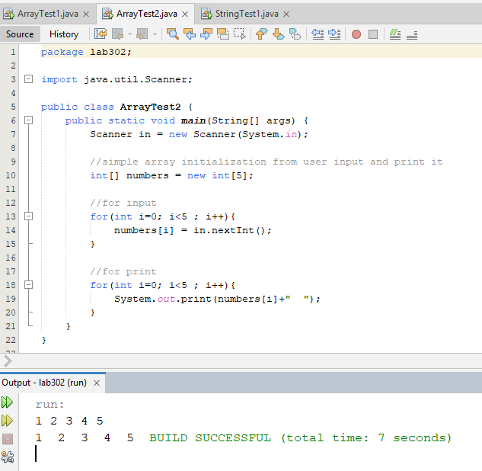

Problem 2. Write a java program that performs string methods like :
i) charAt(); ii) concat(); iii) contains(); iv) equals(); v) indexOf(); vi)isEmpty(); vii) length(); viii) replace();
ix) splits(); x) trim(); xi) toUpperCase(); xii) toLowerCase();
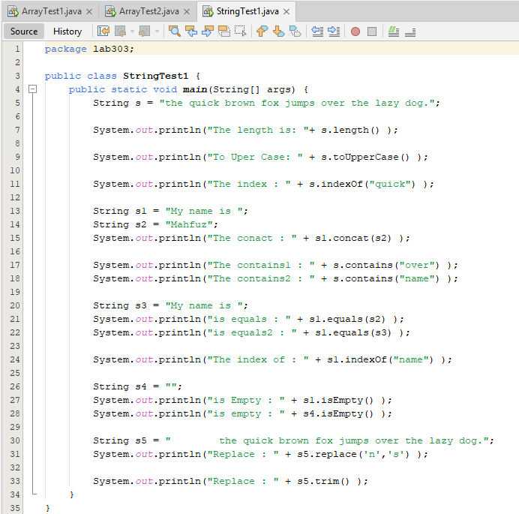
Code:

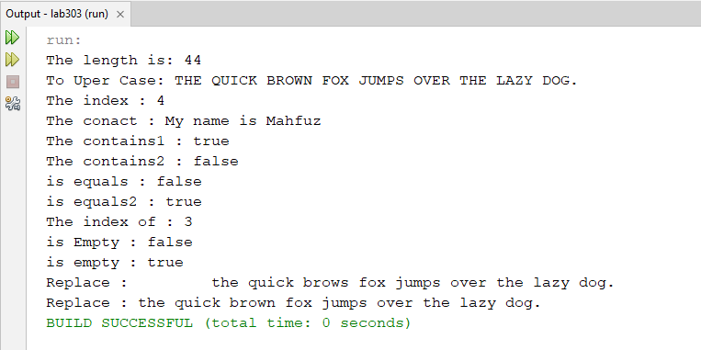
Problem 3. Write a java program to print 1-10 except 5 using continue keyword.
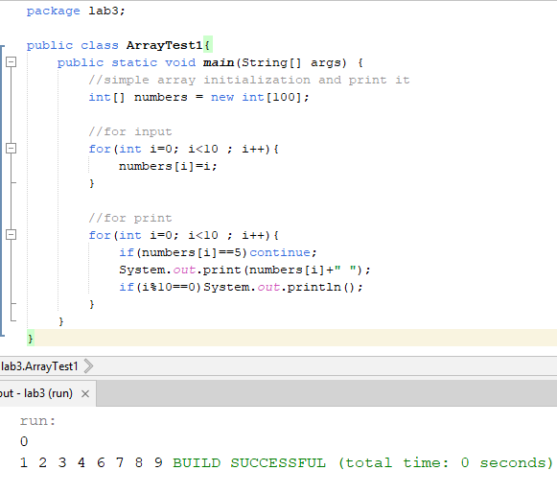
Code:

